

**KAMPALA INTERNATIONAL UNIVERSITY**

**SCHOOL OF MATHEMATICS AND COMPUTING**

**DEPARTMENT OF INFORMATION TECHNOLOGY**

**A REPORT FOR FIELDWORK PLACEMENT CARRIED OUT AT HANDS ON TECHNICAL CENTRE KAMPALA INTERNATIONAL UNIVERSITY**

**FEBRUARY 2023 TO APRIL 2023**

**REG NO: 2021-01-02053**

**NAME: CHEPTOYEK MWANGA DERRICK**

**FIELD ATTACHMENT REPORT SUBMITTED TO THE SCHOOL OF MATHEMATICS AND COMPUTIING IN PARTIAL FULFILLMENT OF THE REQUIREMENTS FOR THE AWARD OF DIPLOMA IN INFORMATION TECHNOLOGY**

**MR. TUMWEBAZE WILSON**

**ACADEMIC SUPERVISOR**

**SCHOOL OF COMPUTING AND INFORMATION TECHNOLOGY**

**KAMPALA INTERNATIONAL UNIVERSITY**

**FEBRUARY 2023**

# **DECLARATION**

I **CHEPTOYEK DERRICK MWANGA** declare that this report is my original piece of work that I prepared and edited as a result of my own effort in attendance, participation and understanding from my internship training at **HANDS TECHNICAL CENTRE (KIU)** and the results in this report have not been presented to any other University or Institute for the award of a degree, certificate or Bachelors in the particular field of study.

Date: ………………… Signature: ……………………

# **APPROVAL**

**Approval from Faculty Supervisor**

I **MR. TUMWEBAZE WILSON** acknowledging that **CHEPTOYEK DERRICK MWANGA** carried out and completed the internship exercise in the stated organization under my direct supervision and guidance

**Date…………………………. Signature…………………………….**

# **Approval from Worksite**

I **MR. LUUMA CHARLES** acknowledging that **CHEPTOYEK DERRICK MWANGA** carried out and completed the internship exercise at my organization under my direct Supervision and Guidance

**Date………………………. Signature…………………………….**

# **LETTER OF SUBMISSION**

**Date: 27/04/2023**

**CHEPTOYEK MWANGA DERRICK**

Dear Sir,

**SUBJECT: SUBMISSION OF INTERNSHIP LETTER**

This is my great pleasure to submit my internship report as a partial fulfillment of a Diploma in Information Technology program to you for your consideration.

I made sincere efforts to study related topics; operating system, repair and maintenance, server 2003 and 2008 management, and finally computer networking.

Within a short time, I had to make this report as comprehensive as possible. But there may be some completeness due to various restrictions. For this reason, I beg for your kind consideration in this regard.

Thanking you,

Yours faithfully

………………………………………

**CHEPTOYEK DERRICK MWANGA**

# **ACKNOWLEDGEMENT**

I would like to give my heartfelt thanks to **Kampala International University** and **Hands on technical center** for their help without any doubts and made the completion of this industrial practical training successful, due to their great contribution. Wholly, I convey my heartfelt gratitude to all for offering their services.

However, I list a number of them. I sincerely thank our Head of the Department **Mr. Asiimwe John** for the excellent Coordination towards the completion of my Field Practical Training.

My practical training could not end successfully without the assistance from different people. I also give thanks to my Trainer and company supervisor **Mr. Ssenyonjo John** for his great assistance during my practical training because he showed me how things are going on and giving me advice when performing different tasks and not forgetting my Supervisor **MR. TUMWEBAZE WILSON.**

I would also love to show gratitude to all my friends who encouraged me to keep going. Their continuous support has given me the strength and confidence to complete the report with ease.

.

# **DEDICATION**

In the first place I dedicate my report to the ALMIGHTY God for the gift of life and enabling me reach this far. I give gratitude to my dear parents who have played the best parts in my wellbeing as a person through supporting me financially, emotionally and not giving up on in my weak and dark days. My dear parents without you there would not be here, so I decide to dedicate this piece of work to you because you have been there for me and may the almighty God continue showering you with His blessings for your unconditional support you have given me so that I managed to finish my internship with ease.

# **ABSTRACT**

This report accounts for all activities that I did and how and why they were done during the time of doing internship training with **HANDS ON TECHNICAL CENTRE.**  This report also shows the experience and skills which I learned during the time of training including the challenges I faced and benefits I learnt.

Chapter one and two give details about my internship, which includes the scope, objectives, and professional area of the internship. They also talk about in details the historical background of the organization where I carried out my internship from, mission, objectives & goals of the company, functions of the company (Their business/services) and Management levels and organization of the company.

Chapter three gives details of the roles and duties I was given to do at HANDS ON TECHNICAL CENTRE**,** and they include computer repair and maintenance, networking and IP address, subnetting, Routering, assembling and disassembling of the system unit including bios settings and configuration

Chapter four gives details of proficiencies gained in carrying out the tasks during internship period (skills), areas of knowledge accumulated in the field (experience) and areas of learning out of exposure, discovery out of knowledge.

Chapter five gives details about the recommendations and conclusions.

# 

# **LIST OF ACRONYMS**

USB: Universal Serial Bus

CMD: command

PC:  personal computer.

CD: compact disc

DVD: digital video disc

ISO: International Organization for Standardization

BIOS: basic input/output system

GB: gigabyte

MB: Megabyte

RAM: Random Access Memory

LAN:  local-area network

RJ:  registered jack

NTFS: New Technology File System

UTP: unshielded twisted pair

IP: Internet Protocol

URL: uniform resource locator

HP: Hewlett-Packard

MFP: multi-function product/printer/peripheral

TABLE OF CONTENT

DECLARATION ii

APPROVAL iii

ACKNOWLEDGEMENT iv

DEDICATION v

ABSTRACT vi

LIST OF ACRONYMS vii

LIST OF FIGURES x

1.0 CHAPTER ONE. 1

1.1 Introduction 1

1.2 Scope of Internship 1

1.3 Objectives of the Internship 1

1.4 Professional Area of the Internship 2

2.0 CHAPTER TWO: EMPLOYER ORGANIZATION 3

2.1 Historical Background of the Organization of Internship Study 3

2.2 Mission of the Company 3

2.3 Objectives of the Company 3

2.4 Goals of the Company 4

2.5 Functions/Businesses/Services of the Company 4

2.6 Management Hierarchy and Organogram of the Company 5

3.0 CHAPTER THREE: WORK DESCRIPTION 7

3.1 Nature of Work 7

3.2 Nature of Work Description 7

3.2.1 NETWORKING 7

Network Administration and Security 8

IP camera configuration 19

4.0CHAPTER FOUR: INTERNSHIP EXPERIENCE AND REFLECTIONS 30

4.1 Lessons learnt during internship 30

4.2 Challenges 30

5.0 CHAPTER FIVE: CONCLUSION 32

5.1 Recommendations 32

5.1.1 Kampala International University 32

5.1.2 The Student for the Future Internship 32

5.1.3 The Organization 32

5.2 Conclusion 32

References 34

# **CHAPTER ONE.**

## **Introduction**

The purpose of this report is to introduce and explain my field internship program at HANDS ON TECHNICAL CENTRE (KIU)which started on February 6th to April 6th 2023. It will mainly uncover the background, mission, vision, objectives, structure, strength, opportunities and challenges faced by the organization.

## **Scope of Internship**

“A form of experiential learning that integrates knowledge and theory learned in the classroom with practical application and skills development in a professional setting. Internships give students the opportunity to gain valuable applied Skills, experience and make connections in professional fields they are considering for career paths; and give employers the opportunity to guide and evaluate talent with the help of supervisors.”

## **1.2 Objectives of the Internship**

The internship Training exercise was aimed at targeting the following objectives;

To allow students to apply, evaluate, test and integrate academic knowledge and theoretical concepts in a work place setting

To develop more understanding about workplace behaviors (ethics), work responsibilities and their challenges.

To ensure skills development through gaining an understanding of the technical, interpersonal and communication skills and another knowledge required in the workplace.

To provide an opportunity to me as a student to apply the techniques I have theoretically and practically learnt while at the university to solve problems that I tend to face.

To ensure Personal development by gaining decision-making and critical thinking skills as well as increased confidence and self-esteem as it is acquired from the managers of the Organization.

To enhance and strengthen linkages between Kampala International University and various stakeholders.

To provide an opportunity for students and academic staff to interact with the stakeholders and potential employers to appreciate field situations that will also generate information for curricula review and improvement.

To allow students to gain access to knowledge and equipment not available on a college campus environment.

## **Professional Area of the Internship**

I put more of my effort in the area of Information technology specifically computer repair and maintenance and routing.

# **CHAPTER TWO**

## **EMPLOYER ORGANIZATION**

## **2.1 BACKGROUND OF THE COMPANY**

KAMPALA INTERNATIONAL UNIVERSITY (KIU), commenced operation as a private University in October 2001. The university offers both undergraduate and post-graduate programs on full-time as well as part-time basic.

Kampala International University was founded seventeen years ago and has two campuses; the main campus in Kampala along Kansanga, Ggaba road and the school of Health sciences (KIU Western Campus) in Bushenyi along Kasese road, with branches in Kenya and Tanzania.

## **2.2 MISSION OF THE COMPANY**

To respond to Social needs by designing and delivery of education guided by the principles and values of respect for society, economy and environment to provide and develop a supportive research environment in which scholars at every stage of their career can flourish.

## **2.3 OBJECTIVES**

### **2.3.1 GENERAL OBJECTIVE**

To equip our esteemed students with the most important source of information, personal performance accomplishment, via frequent computer exercises and laboratory activities, requiring regular demonstration of computer hardware and software understanding and proficiency.

### **2.3.2 SPECIFIC OBJECTIVES**

* To carry out preliminary networking tasks such as installing operating systems and configuring them for networking, terminating straight through and cross over cables in preparation for networking.
* To acquire the necessary skills, personal qualities, attributes values and learn career related skills.
* To carry out advanced networking practices such as sub netting and configuration.
* To identify all computer components both internal and external, and to learn their functionality and importance in a computer system.
* To get more skills on computer hardware materials such as repair and maintenance.

## **2.4 GOALS OF THE COMPANY**

The company’s goal is: “to explore heights”.

## **2.5 FUNCTIONS OF THE COMPANY (SERVICES OFFERED)**

* It helps to equip students with internship IT and ICT skills.
* It motivates others in terms of graduates worldwide about computer skills.
* It provides employment to lecturers, none staff members, and teachers.
* It helps in educating the people or society.
* It provides computer training services.
* It provides information technology consultation services.
* It provides computer cores, care, repair and maintenance.
* It provides services on Network and Internet.
* Provides internship placements to all kinds of students from different departments in the world.
* It provides employment opportunities to all kinds of ICT and IT work.

## **2.6 MANAGEMENT HIERARCHY AND ORGANOGRAM**

**University council**

**University principles**

Chairman council

Chancellor

Vice chancellor

Deputy vice chancellor (Academic affairs (Western campus))

Deputy vice chancellor (Academic affairs (main campus))

Deputy vice chancellor (Finance and administration)

Deputy vice chancellor (Research and innovations)

Principles

Directors

Heads of department

Guild (Students representatives)

Lecturers

Students

Non-teaching stuff

# **CHAPTER THREE**

## **3.0 WORK DESCRIPTION**

This chapter describes details of the nature of the work we carried out and also illustrates the steps and methods we used in carrying out these tasks.



## **Nature of Work**

This chapter briefly describes various nature of work that I involved myself as I was at Hands on technical center (KIU). It shows the activities that I did and describes how exactly I performed such work.

This included;

* Networking
* Network Administration
* Ip address and sub netting
* Router and switch configuration
* Computer hardware and software maintenance
* Assembling and disassembling of the system unit
* Bios setting and configuration

## **Nature of Work Description**

**3.2.8 ASSEMBLING AND DISASSEMBLING OF THE SYSTEM UNIT**

**ASSEMBLING THE SYSTEM UNIT**

This was not so hard since I had an idea about the different core computer components and their functions.

This activity required a safe secure environment and I considered a large flat working area, comfortable room temperature, good ventilation, enough light in the room and a dust free environment.

**Steps I followed when assembling the system unit**

1. Opened the case by pressing the side buttons on it while sliding towards me.
2. Installed the power supply into the case to its alignment holes and specific placement with the holes on the case. I made it firm by fixing using a screw driver.
3. Attached components to the motherboard. This was important to attach the components before attaching it to the case.
4. Installing CPU and heat sink fan to the motherboard. This was by aligning the CPU in connection 1 indicator lined up with pin 1 on the CPU socket and gently lowering the CPU in the zero-insertion socket. I then closed the CPU load plate and locked it by closing the load level.

I lined up the heat sink/fan assembly retainers to the hole in the motherboard. After, I placed the heat sink onto the CPU socket being careful not to pin the CPU fan wires. Now the sink power had been connected to the motherboard.

1. Installing RAM. I aligned the notches on the RAM module to the key in the slot and pressed downwards until the side tabs clicked into place. I then ensured that the side tabs had locked the RAM module.
2. Installing the motherboard. I placed the standoffs in the computer case, these are used to mount the motherboard and prevent it from touching the metal portions of the case. I aligned the I/O connectors on the back of the motherboard maintaining the openings at the back of the case. I aligned the screw holes of the motherboard with standoffs. After, I tightened the screws onto the case so that the motherboard is held firmly onto the case.
3. Installing the internal drives. I placed the hard disk drive such that it aligned with the 3-5-inch drive bay, ensuring that it was set to be the master on the IDE cable since each cable can support up to two IDE devices such as hard drive, cd drive. This works when one of the devices is made master and the other slave and this must be configured in the BIOS after. I inserted the HDD into the drive bay so that the screw holes in the drive lined up with the screw holes in the case and screwed them tight.
4. Installing drives in the external bay. These include drives installed in the drive bays that are accessed from the front of the case and they include the optical drives.
5. Installing the optical drive. I positioned the optical drive to align with the drive bay and placed the optical drive into the bay so that the drive screw holes align with the screws on the case and connect the sound cable of the drive for the output of audio data to work well.
6. Installing floppy drive. I fixed the floppy disk drive to align with the 3.5-inch drive bay and then placed the drive so that the screw holes align with the holes on the case. I ensured it was held firmly onto the case.
7. Installing adapter cards. These add functionality to a computer system and they should be compatible with expansion slots. They include network interface card, wireless card etc. I aligned the cards to their appropriate slots on the motherboard, then pressed downwards gently until they were seated and held tight.
8. Connecting internal cables. There are two types of internal cables, power cable and data cable. I connect these to their respective connection points and made sure they were firmly held.
9. Re-attaching the side panels and connecting external cables. After installing all the internal components, I then re-attached the side panels to the computer case. Then finally, I fixed back the external cables such as mouse, keyboard, and serial cable for the monitor, usb connector for peripherals like printers, scanners, Ethernet rj-45 connector etc.
10. When all was finished, I plugged the power cable into the wall socket and switched on my computer and it worked perfectly well.

This is a form of a box which gives protection to all the internal components of the computer. It serves mainly as a way to physically mount and contain all of the actual components inside of a computer. There are two types of casings i.e. desktop and tower.

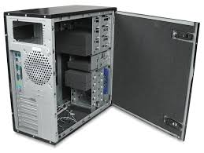

Figure 2: The computer case

**The monitor**

This is an electronic visual display for computers. It is used to display information on the screen. All the activities of a computer, functions and tasks are seen on the computer screen and this is called outputting information. Today, most computers use LCD screens also known as flat screens.

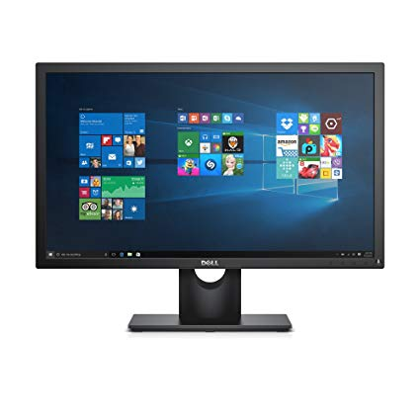

Figure 3: The monitor

**The keyboard**

This is used to type information or input information to the computer. A standard keyboard has 101 keys and embedded keys. The most common layout of the keyboard is QWERTY layout



Figure 4: The keyboard

**The mouse**

A mouse is a pointing device used for inputting information into a computer and also executing commands on a computer. It has two buttons, left and right to perform different functions.

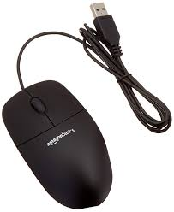

Figure 5: The mouse

**The central processing unit**

It is often referred to as the processor, and is the brain of the computer. This is the chip that performs the majority of calculations and instructions needed to make your computer run. Without this chip, no function of the computer is possible. The processor is attached to the motherboard.

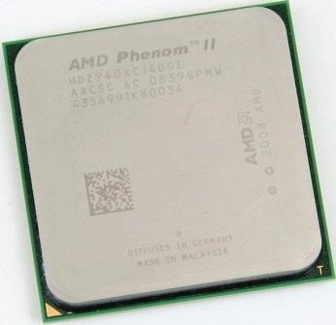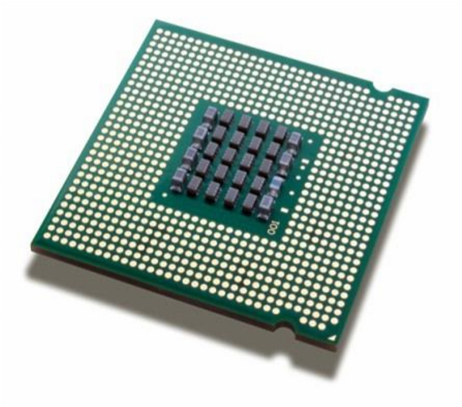

Figure 6: The central processing unit.

**The motherboard**

This is the printed circuit board in many modern computers and it holds many of the crucial components of the system, while providing connectors for other peripherals. Also called the mainboard, the motherboard is a large, thin flat, rectangular fiber glass board attached to the case. Motherboards include components like sockets (slots) in which one or more microprocessors may be installed, memory slots into which the system’s main memory is to be installed, a chipset which forms an interface between the CPU’s front-side bus, main memory, and peripheral buses, slots for expansion cards, power connectors, non-volatile memory chips and a clock generator which produces the system clock signal to synchronize the various components. The motherboard provides the centralized connection point for the computer’s components.

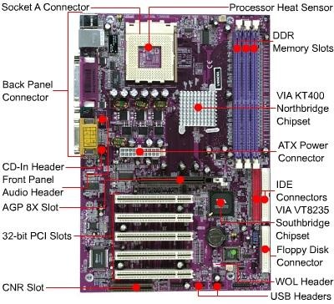

Figure 7: The motherboard

**The power supply**

The power supply supplies DC (Direct Current) power to the components in a computer. It converts general purpose (AC) Alternating Current electric power from the mains (220V-240V at 50Hz) to low-voltage (for desktop computers: 12V, 5V,5VSB, 3VE, -5V, and -12V) direct current.

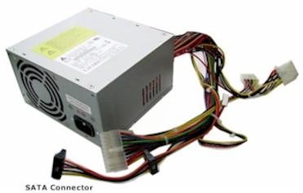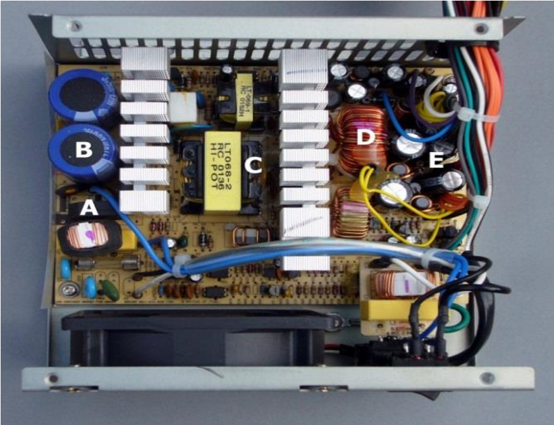

Figure 8: The power supply

**Uninterrupted power supply (UPS)**

An uninterruptable power supply (UPS) takes its power from two or more sources simultaneously. It is usually powered directly from the AC mains while simultaneously charging a storage battery. Should there be a dropout or failure of the mains, the battery instantly takes over so that the load never experiences an interruption. Such a scheme can supply power as long as the battery charge suffices, e.g. in a computer installation, giving the operator sufficient time to affect an orderly system shutdown without loss of data.

The Front and Back end of a UPS

The Interior of a UPS

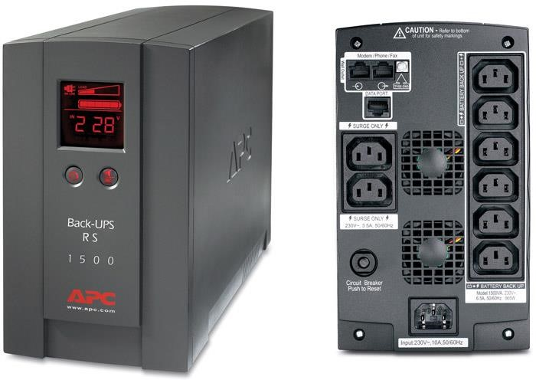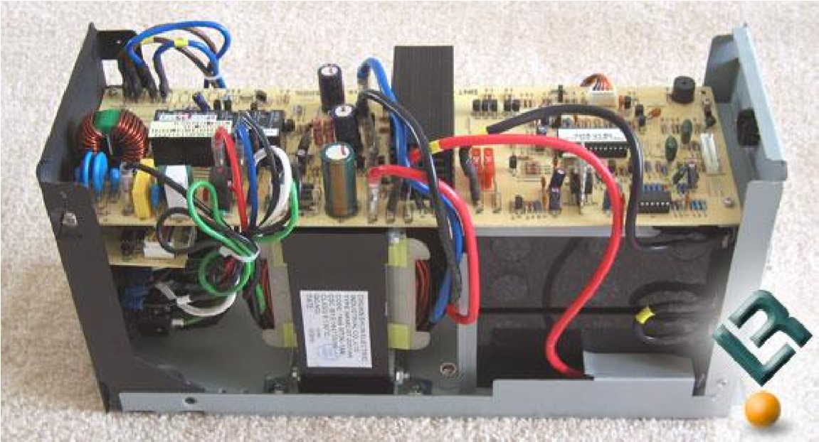

Figure 9: The UPS

**Computer memory**

Memory is the term used to describe devices that enable the computer to retain information. Program instructions and date are stored in memory chips for quick access by the CPU. It consists of one or more chips on the motherboard. Memory chips can either be RAM or ROM.

**RAM (Random-Access Memory)** - has the form of intergraded circuits that allow stored data to be accessed in any order with a worst case performance of constant time. RAM holds the data or instructions that the CPU is presently processing. RAM is volatile i.e. the memory’s contents are erased when the power is turned off.

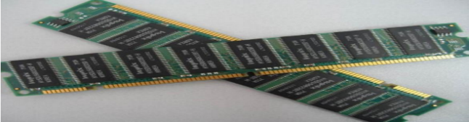

Figure10: RAM chips

**ROM (Read-Only Memory)** - is a memory chip that stores instructions and data permanently. Its contents are placed into the ROM chip at the time of manufacture and can’t be modified by the user. Such information includes firm ware of the computer for example: its brand name, the manufactures name, date of manufacture, its model among others. ROM is non-volatile and therefore its contents are not lost when the computer is turned off. Such chips include the BIOS chip as shown below;

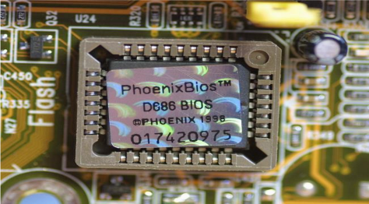

Figure 11: BIOS chip as an example of ROM

**The hard disk drives**

A hard disk drive is a device that is used to store large amounts of data in a computer system. Hard Disk Drives differ from other memory because they are non-volatile: they retain data even when they do not have power. There are three basic configurations of a Hard Disk Drive i.e.

* + **Master:** This is where the Operating System and Boot files reside. Only one Hard Disk Drive can be a Master.
  + **Slave:** This is where Hard Disk Drives are connected.
  + **Cable select:** Looks for boot files and the Operating System installed else recognize the Logical Drive. A piece of metal that helps to set the Hard Disk configurations is called a **Jumper**

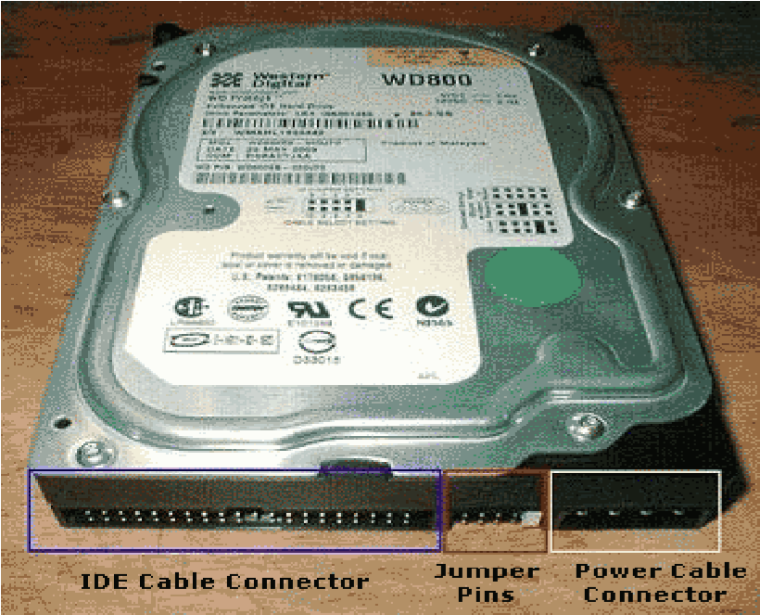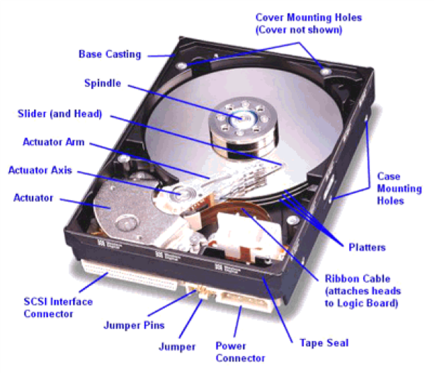

**Figure 13: Exterior of a hard disk**

Figure 12: Interior of a hard disk

**DISASSEMBLING THE SYSTEM UNIT**

Tools required include; soft wide bristle brush, long Phillip screw driver, blower, screw, driver box etc.

* Before opening the system case, I turned off the system unit. I turned off and unplugged the AVR from the wall socket as well. After that, I unplugged all the cables connecting to the back of the system unit. I then put the system unit on an empty working table.
* I touched the unpainted part of my system unit with, my bare hands to remove the ESD of my body. This is an important part before opening my system case. This was to avoid destroying the RAM, chipsets and other components of my motherboard.
* I removed the screws of the side cover opposite to the side where the ports were. By most system cases, if you are facing the back of the system unit, the right-side cover is to be removed. I returned the screws back to the screw holes to avoid losing them.
* Once the side cover was removed, I turned my system unit upside down where the opened side was facing upward and I could comfortably look down on the inside of the system case.
* The first thing I did was to remove the power supply. First, I removed the Molex connectors or the motherboard power connector, drive power connectors, the floppy drive power connector, the SATA power connectors, and the four pin 12-volt motherboard connector.
* With the power supply removed, I removed the data cable next. This included IDE, SATA, and floppy drive cables. I secured the removed data cables.
* Next, I removed the RAM, video card and other card peripheral components. I again had them secured in a safe place. I cleaned the connector edges of the card peripherals by rubbing the gold colored edge moderately with a rubber eraser then brushing off the shredding.
* I removed all the drives. These were the hard drive, cd/DVD drives, and the floppy drive.
* I then removed the front panel connectors which included the USB, front panel and audio header.
* After removing the header connectors, I removed the motherboard. To remove it, I first located all screws and lightly unscrewed all of them alternately.
* I cleaned the system chassis with a brush, the motherboard and cleaned all the other peripherals.

## **OPERATING SYSTEM**

Operating system is the core software component of your computer. It is the software that controls functionality and provides lower-level routines for applications. It performs many functions and is, in very basic terms, an interface between your computer and the outside world. In the section about hardware, a computer is described as consisting of several component parts including your monitor, keyboard, mouse, and other parts.

### **3.3.1 METHODS OF INSTALLATION**

* **Clean installation**: This is normally done on new system or in cases where no upgrade path exists between the current operating system and the one being installed. a new computer system requires a clean installation. It is also performed when the existing operating system installation is damaged in some way.
* **An Upgrade installation**: If staying within the same operating system platform, it is often possible to an upgrade, system configuration settings, applications and data are preserved. It simply replaces the old operating system with the new operating system files for example from windows 7 to windows 8.
* **Multi-booting/Dual installation**: It is possible to install more than one operating system on a computer to create a multi-boot system. Each operating system to be run on a single set of hardware, thus creating, many virtual machines. Each virtual machine can be treated as a separate computer. This enables a single physical resource to appear to function as multiple logical resources.

### **3.3.2 REASONS FOR OPERATING SYSTEM**

* **File management-**The file manager allocates the resources by opening the files and reallocates the resources by closing the file.
* **Resource management-**It allocates computer resources such as CPU time, main memory, secondary storage, input and output devices for use.
* **Data management-**It governs the input and output of data and their location, storage and retrieval. This is done by allocating the data and the program files of the computer for the use.

### **3.3.3 TYPES OF OPERATING SYSTEM**

We looked at the two types of operating system namely;

* Closed source operating system for example windows XP, windows 2007, windows 9.5.
* Open source operating system for example Linux, Zorion, Ubuntu, Centox, and Fedora.

### **3.3.4 COMPUTER MANAGEMENT**

Under computer management we were able to look at following.

* Creating partitions, hiding the partition, restoring it, deleting the partition, setting up a proxy, restoring a web menu for Mozilla and explorer.

### **3.3.5 INSTALLATION AND CONFIGURATION OF OPERATING SYSTEM**

**Steps followed when installing windows 7**

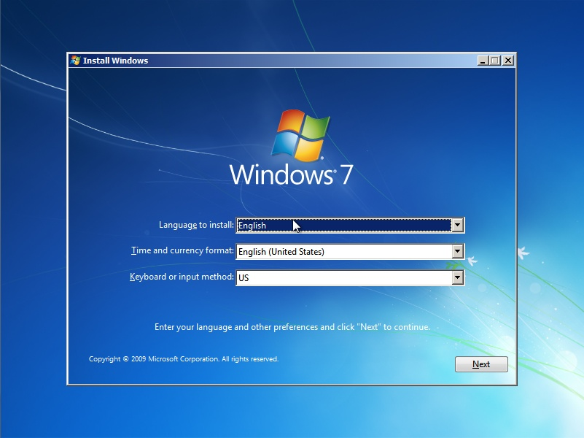

* We inserted the Windows 7 CD into the system’s CD/DVD drive.
* Press Ctrl+Alt+Del keys for restating.
* Press f9 for set up.
* Press f8 to repair or to install on a fresh copy.
* Select where you want to install from like CD, flash or hard disk.
* We configured the system to give the option of booting from the CD in the System BIOS.
* We saved the BIOS settings and restart the computer.
* When prompted to boot from CD, press any key to start with the installation.
* The Windows 7 Setup main screens appears, and then press Enter to continue.
* We accepted the Microsoft End User License Agreement (EULG).
* Setup the disk to accept Windows 7 with the different file systems like FAT32 and NTFS. But it is best to choose NTFS for performance reasons.
* The setup now formats the partition as specified and copies file needed to start the graphical portion of setup.
* Install devices in the setup.
* Windows finish to install by copying all the remaining necessary files, puts items on the start menu, builds the registry and cleanup after itself. This takes several minutes.
* The setup then reboots the computer.
* After rebooting, we updated the drivers for hardware components with the most current drivers fir these items like
  + Motherboard and chipset
  + Video card
  + Network card
  + Sound card and
  + Disk controllers
* We restore user data files
* We verified installation by rebooting again to make sure that all the appropriate programs and devices are working properly.

### **NETWORKING**

Networking is the process of connecting two or more computers to store given resources

**REQUIREMENTS FOR SETTING UP A NETWORK**

* Client and host server
* Routers/modem
* protocols

**Examples of networks**

* LAN (Local Area Network)
* PAN (Personal Area Network)
* MAN (Metropolitan Area Network)
* WAN (Wide Area Network)

NETWORK ADMINISTRATION

**Components of a network**

* Network interface card
* Terminal nodes e.g. Computers and Printers
* Communication (Network) media/Channels e.g. Ethernet cables and access point
* Network software e.g. network operating system.
* Switches or hubs

### **Network Administration and Security**

A computer network is an interconnection of two or more electronic devices with the purpose of sharing information. During my internship, I was taught networking topologies and methods of cablings, configuration of IP addresses and their verifications, networking tools and how each one works, the network threats and how they can be avoided, termination of networking cables, setting up of a wired and wireless LAN network, sharing resources, sub-netting, procedures for WAN, methods of boosting the signal for long distances, troubleshooting network problems, among others.

**Requirements for network administration**

* Operating system (os)e.g. Linux, Windows e.g. (office program)

**Network hardware devices**

* Routers
* Switches
* Hubs
* Repeaters
* Bridges
* Network Interface Cards (NICs)

**3.2.2 CABLING**

**Common network cables**

* Twisted Pair
* Coaxial Cable
* Fiber Optic Cable

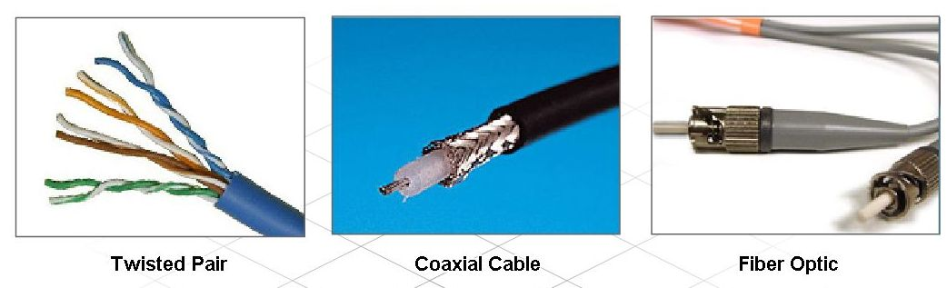

**Cable termination**

Cable Termination is the connection of the wire or fiber to a device, such as equipment, panels or a wall outlet, which allows for connecting the cable to other cables or devices.

**Tools used include**

Clipping tool

Ruler

Cable

RJ-45

Cable tester

**There are two types of cable termination practices;**

1. Straight through termination

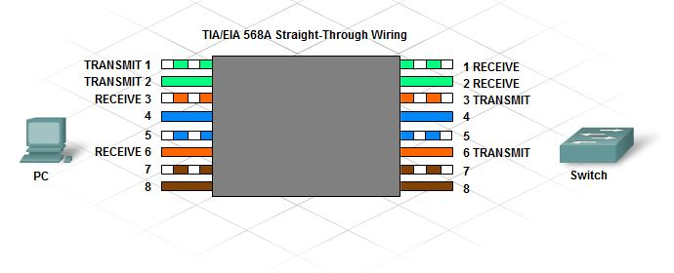

1. Crossover termination

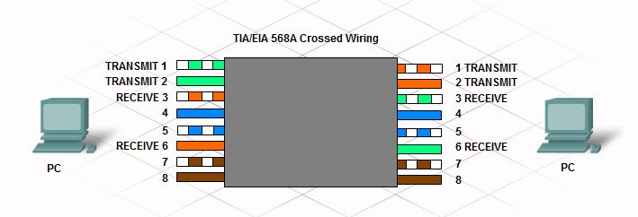

**Cabling best practices**

* It is important that the type of cables and components used on a network adhere to the standards required for that network.
* Always adhere to the length restrictions for the type of cable being installed.
* It is important to install cable away from sources of interference such as high-voltage cables and fluorescent lighting.
* Always follow the rules for cable termination and test to verify that the termination has been done properly.
* Test all cable installations to ensure proper connectivity and operation.
* Label all cables as they are installed, and record the location of cables in network documentation.

**3.2.3 IP addressing**

We defined an IP address as an address used to uniquely identify a device on an IP network. This simply means that every device connected to a network must have an IP address so that information from the sender goes to that address.

**IP ADDRESS**

**Is num**erical when assigned to each device connected to computer network that uses internet protocol for communication.

**TOOLS AND EQUIPMENT USED**

* Desktop computer
* Whiteboards

**TYPES OF IP ADDRESS**

* **Ipv6**
* **Ipv4**
* **APIPA:**

Is the one that connects automatically on the machine

* **Loop back**

**EXAMPLES OF EACH TYPE**

**Ipv6**

* Unicast (one to one)
* Multicast (one to many)

**Ipv4**

* Private (free)
* Public (unique and global)

**IP address classes**

|  |  |
| --- | --- |
| Class A | 1 – 127 |
| Class B  Class C  Class D  Class E | 128 – 191  192 – 223  224 – 239  240 – 255 |

**Private addressing space**

Class A 10.0.0.0 to 10.255.255.255

Class B 172.16.0.0 to 172.31.255.255

Class C 192.168.0.0 to 192.168.255.255

**3.2.4 Subnet masking**

A subnet mask is a 32-bit number used to differentiate the network component of an IP address by dividing the IP address into a network address and host address. It does so with bit arithmetic whereby a network address is bit multiplied by the subnet mask reveal the underlying sub network.

**Default subnet masks**

**Class A** 255.0.0.0

**Class B** 255.255.0.0

**Class C** 255.255.255.0

**Sub netting**

**Sub netting formulas benefits and how to create**

**Sub netting is the division of bigger network into smaller network**

Example

10.00.0 network identifiers

255.0.0.0 default network mask

Sub netting formula

2^n >=x

Where x is number of departments you want to subnet e.g. dealing which two classes the number x=2

**Benefits of sub netting on a private IP network**

* Improved network security
* Improved network performance
* It helps to maintain clean separate within a network
* It helps to relieve network congestion
* It identifies a network with range of internet protocol addresses in the internet

**Designing and applying an IP addressing scheme**

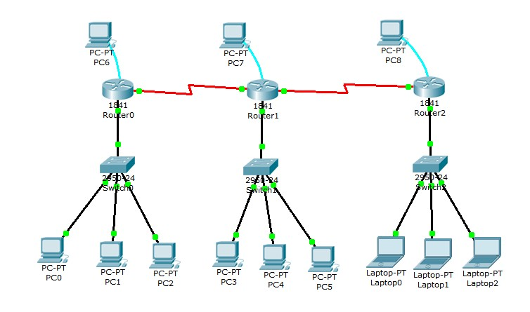

**Tools and equipment used;**

* Computer set (monitor, system unit, mouse, keyboard)
* Note book
* Pen
* Hard disk drives
* Flash disks
* Switches
* White board

**3.2.5 Router and Switch Configuration**

A route is a networking device that provides data packets between computer networks

**Tools used**

* Screen
* laptop

**A route has four modes under to config from:**

* User mode e.g. router>
* Privilege mode Route#
* Global configuration mode e.g. (config H)
* Interface mode Router (config if)

**List of commands used in Routers**

* Ctrl +z takes you to privilege mode
* Running config shows the RAM and interfaces of the computer
* Enable**:**

Helps you to move from user to privilege mode

* Conf t

It helps to move from privilege mode to global configuration

* Interface f0/0

It helps to move from global to interface mode

**A router has four modes as shown in the diagram**

|  |
| --- |
| User mode  Router> |

enable

|  |
| --- |
| Privilege mode  Router if |

|  |
| --- |
| Configuration mode  Router (config#) |

Ctrl +z exit conf t

|  |  |
| --- | --- |
| Interface mode  Router (config if H) |  |

F0/0

## **CONFIGURATION OF WINDOWS SERVER 2003**

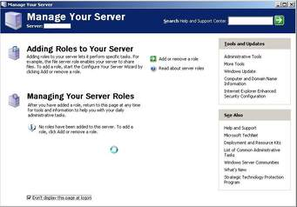

**3.3.1. How to assign the IP address on the computer server.**

One has to make sure that the server computer is connected to switch or any other network device. This is because server is designed to control other device; hence it must be connected to at least one device.

Click on start menu, double click on control panel. Double click on network and internet, double click on network connection, right click on local area connection, click on internet protocol version (TCP/IP), and click on properties.

If you want to sign it automatically, click on obtain an IP address automatically. If manually, click on the following IP address. Enter the IP address and click on OK button.

**3.3.2 How to configure the licensing of the server computer.**

Click on control panel, double click on administrative tools, double click on services, and click on properties of licensing.

Click on local system account of the log on, then click on general select the start-up type automatically, click on apply, click on start and OK button.

Again click on panel, click on licensing click on add license, quantify, any, OK and click on agree.

**3.3.3. How to set a password policy**

Before setting a pass word policy, the active directory be configured first. This is done to enable domain security policy and domain security controller appear on the administrative tools.

**3.3.4. Configuring Active Directory**

Click on manage your server, click on add or remove, click on custom configuration, click next, click on domain controller policy (active directory), click x3. Click on domain controller, click on domain in the new forest, next, enter your domain name and click next x4, click on permission compatible only windows 2000 or windows server 2003 and click next, type in restore mode password, confirm password and click next x2, finish and restart the computer, after click finish.

**3.3.5. Setting Password Policy**

Click on administrative tools in the control panel, click on domain policy, expand account policy, click on password policy, click on properties of the minimum password length, tick on define this policy settings, apply and OK, then click on the properties of password must meet its complexity, disable and click OK button.

Again click on administrative tools, click on domain controller security policy, expand local policies, user right assignment, right click on the properties of allow logon locally, enter your group name like student, apply, OK. Then go to DOS command, type in ‘‘GP update’’ and press ENTER for updating the settings.

**3.3.6. Moving Objects within Active Directory.**

Click on administrative tools, active directory user and computer; right click on domain, new, organization unit, next.

Move back to user; right click on group name, move, and organization unit.

**3.3.7. Creating a Shared Folder and Applying Share Permissions.**

Click on my computer, select the disk, create a folder, right click on it, and click on share and security, share folder, enter a share name, description, user limit, allow, permission, add, advanced, find now, search result, select the person, OK, allow, control or not, OK.

**3.3.8. Enabling Web Service Extension**

Click on manage your server, add or remove, next, application server (IIS, ASP, Net), next, enable ASP.NET, next x3. Then click on administrative tools, internet…, we service extension, allow all the contents.

**3.3.9. Hosting a Website**

Click on administrative tools, IIS, website, right click on it, new, website, enter description, next, select IP address, next, browse, select the website, OK, finish.

**3.3.0. Managing Website**

Click on administrative tools, ISS, click on the properties of the website.

Performance, limits the network band width website connection, connection limited, and applies, OK. Then go to home directory, script and executable. Then to HTTP, enable content expiration, apply, OK.

**3.3.1. Configuration of Terminal**

From the administrative tools, click on terminal services configuration, connection, click on the properties of the RDP, general, encryption level (high), logon settings, always use the following logon information, session, override user setting. Idle session limit, remote control, user remote control with the following settings, require user’s permission, interact with the session, client settings, use connection setting from user setting, limit maximum color depth, network, adapter, maximum connection, all network adapters configured with the protocol.

**3.3.2. Managing a DHCP server**

From the start menu, click on manage your server, add or remove, DCHCP, name of the scope, description, next, enter, enter the starting IP address and the ending IP address, length, subnet musk, next, add exclusion, enter the starting IP address and ending IP address, add, next, lease duration, days, next, configure DHCP router, if you have router, click on YES, if you don’t click on NO, next, finish.

After configuring the DHCP you need to manage it by clicking on the manage your server, manage your URCP, expand the domain, expand scope, address pool, right click on address pool, activate, if you want to create a new scope, repeat the same procedures.

**3.3.3. How to ensure security such that data is protected between the client and server**

Click on run, type in MMC, OK, file, add or remove snap-in, add, group policy object editor, choose local computer policy, click on extension, extended view, finish, OK, expand local computer policy, expand computer configuration, expand window settings, security settings, IP security, right click on server request, assign, right click to server request again, properties, rules, all IP traffic, apply, OK, and select the position you have want.

**3.3.4. How to add network services.**

Click on control panel, add/remove, add/remove windows components, ENTER, ‘‘tick management and monitoring tools, other network files and printer services, network services’’, next, finish.

**3.3.5. How to capture data with network adapter**

Before capturing data you have to configure the network monitor first by clicking on control panel, add/remove, add/remove windows components, and ENTER, management and monitoring tools, next, OK, finish. Then go to administrative tools, network monitor, capture, buffer settings, buffer size, OK. Back to capture, start, add, close, and then back to capture, click on stop, go to file.

**3.3.6. How to Create a Display Filter.**

Click on administrative tool, network, file, open, open the saved document, display, filter, protocol, edit expression, disable all, HTTP, enable, OK, any <-> any, edit expression, protocol, DHCP, enable, OK, save.

**3.3.7. How to Enable IP Security on Local Computers**

Click on run, type in MCC, OK, file, add/remove snap-in, add, group policy object editor, add, browse, default domain policy, OK, finish, close, choose, click on extension, group policy editor, extended view, OK, expand default domain policy, expand computer configuration, expand window settings, expand security settings, IP security policies and active directory (domain), right click on server request, assign, file, save.

**3.3.8. How to create a demand-dial interface**

Click on administrative tools, routing and remote access, expand computer name, right click on network interface, new-demand-dial interface, next, interface name, click on connect using virtual private network (VPN), next, automatic selection, next, ENTER, type in the host name/IP address, next, click on route IP packets on this interface, next, add, type the destination, network musk IP address, OK, next, type a user name, domain, password, conform password, next, finish, then right click on the created demand-dial interface, properties, option, demand-dial, set time for hanging out, security, tick on typical (recommended settings), tick on require data, encryption, network settings, set type of VPN automatic, OK.

**3.3.9. Installation of the RIP and OSPF**

Click on administrative tools, routing and remote access, expand IP routing, general, OSPF, back to general, right click on it, new routing protocol, add, go, OSPF.

**3.3.10 How to Add/remove Static Router**

Click on administrative tools, routing and remote access, expand IP routing, right click on the static route, interface, and choose local area connection, type in the destination, network musk, gateway IP address, OK.

**3.3.11. How to Create the PPTP Packet Filter**

Click on administrative tools, routing and remote access, expand IP routing, general, right click on local area connection, properties, inbound filter, new, click on destination, enter IP address, subnet musk, protocol (TCP), enter ports, OK, new, click on destination again, enter the IP address, subnet musk, protocol (ANY), OK, new, click on source network, enter IP address, subnet musk, protocol (TCP), enter ports, OK, new, click on source network, enter IP address, subnet (ANY), OK, tick on drop all packets.

**3.3.12. How to configure a wireless router**

Go to windows explore, type in IP Address of the router 192.168.10.1, enter, enter password and login, enter, basic settings, if internet requires a login click YES if not click NO, select encapsulation, login, password, tick on use static IP address, enter IP address from that one you reserved when configuring the DHCP, tick on use these DNS servers (are given by the ISP- internet service provider), go to NAT (Network Address Translation), enable, click on ADSL settings, multiplex method, click on VC-based, block sites, tick on always, type keyword/domain name which you would like to block, click on firewall rules, click on services, click on schedule to set the start and end time for internet usage, click on e-mail, click on router status, click on attached device to see the computers attached on the network using MAC address, click on set password to set the old password, new password and then confirm the new password. Click on diagnostic, ping and IP address to see whether all the computers on that router are communicating, click on router upgrade, click on LAN settings, click on remote, tick on turn on remote management on, tick on only this computer, click on static router, add, yes, private, enter destination IP address, IP subnet musk,. Gateway address, apply, click on UPnP.

**3.4 Installation of windows server 2008**

The installation of any windows operating is almost the same windows server 2008 installation procedure is almost the same that of windows 7. After installation is completed successfully, the next step is the configuration of the server as to enable it to its functions. It’s recommended to run the driver pack before attempting to configure or install any server roles. The items below are too vital when setting up a server on a network;

* Active directory
* Domain controller
* Domain
* Server role
* Domain name system (DNS)

**3.4.1 Configuration of server roles**

The first windows that appear after installation of windows server 2008 is the initial configuration task list (ICT). This window prompts the administrator to configure and set a number of tasks which are so vital before configuring the roles. These tasks include;

* Time zone information
* Network settings
* Automatic updates
* Remote desktop

**3.4.2 Date and time configuration**

From the initial configuration task list, select the date and time link. The window below will open

**Illustration**

From the above window, select the change date and time option

Set the right time and date

You can as well change the time zone as per the area.

**3.4.3 Network settings**

From the initial configuration task list, select network connection

Click on the local area network

Enter IP address, subnet mask and the DNS in the window as below.

Illustration

**3.4.4 Automatic Updates**

Click on change settings

Set whether updates should run automatically whenever available or first require confirmation from the administrator. The window below displays all options one can take in regard to updates setting

Illustration

**3.4.5 Remote Desktop Setting**

In the ICT, under system properties select the remote desktop option.

From the window that appears, select an option to allow remote desktop connection from other computers. The window looks below;

Illustration

**3.4.6 Server Roles**

A server role is a major job that a server. It’s recommended that a server should not have too many roles. Domain controllers usually have only two roles.

Active directory domain services

DNS: is a service provided by the server that allows one to find other computers in a network. It allows one to type in a friendly name of a machine instead of its IP address, allowing client to get the IP address from the DNS server and find the resources. Without DNS, active directory will not work.

**3.4.7 Domain Controller**

A domain controller is a windows server machine that runs active directory services. Multiple domain controllers can have copies of the same active directory database.

Setting up a domain controller has two basic parts;

1. Installing the active directory domain system role; this is done from server manager using “add roles”
2. Running the DCpro.exe; this can be ran from the link provided in the server manager after active directory domain system installation or from the search box.

**3.4.8 Name space**

A windows server domain is local group of computers running a version of Microsoft windows operating system that share a central directory database. The machines are all named with part of domain name “like Microsoft.com” and are registered in the active directory database so they can be managed. Users are also part of the namespace such as an email is part of a domain namespace.

**3.4.9 Forest**

A forest is comprised of all the domains in an enterprise. A forest may have one domain. A root is the first domain in forest.

**3.4.10 Active directory**

Is the brain of a windows server Network. It is a database that keeps track of a he amount of activities, data and information and gives a centralized way to manage all network machines, users and resources.

**3.4.11 Installation procedure.**

Click on server manager

Click on roles

Click on add roles

**Illustration**

In the windows that appears, click next

The window below appears.

Select active directory domain service options and click next.

Illustration

Wait for the system to install the active directory.

The windows below will appear while the server is creating the database and completion, the system must start.

Illustration.

When AD Ds is installed successfully, install the DC promo. This makes the system a domain controller with an active database.

Illustration

Organization units, users, computer accounts and groups.

**Organization unit (OU)**

It is a container that holds AD objects like accounts, computer accounts, and groups. OU’s help to keep objects organized but also to control what users’ can and can’t do.

### **SUBNETTING.**

This refers to breaking larger network into smaller network.

#### **REASONS FOR SUBNETTING.**

* To avoid traffic, eases trouble shooting. Eases performance.
* Easy management of the network.

#### **CALCULATING THE NETWORK ADDRESS, NUMBER OF SUBNETS AND NUMBER OF HOSTS.**

* Network address is a product of sub net mask (SM) bits and IP address bits.
* N.A=SM and IP ADDRESS OR N.A =SM IP address
* Number of sub nets =2n where n=total host bits
* Host bits are represented by 0 were as network bits are represented by 1
* Number of host=2n-2

# **CHAPTER FOUR**

## **4.0 INTERNSHIP EXPERIENCES AND REFLECTIONS**

## **4.1 WHAT I HAVE LEARNED?**

The followings below is what I have learned;

* **Computer Networking, installation of operating system, maintenance and administration.**

Under these activities, we looked at identifying network components and topologies, terminating of network cables, Remote access of computer and Net meeting.

* **Remote access of computers.**

We looked at remote desktop connection, here we able to connect to some computer remotely and we shared files, and we deleted some file from another computer while in remote.

* **Net meeting and Messenger.**

We also looked at net meeting here we connected to computers and we were able to send messages, chart and making calls without any cost while not connected on internet.

* **Identifying network components and topologies.**

This was done by visiting the company server room and components like routers, switch, modem, Repeaters; network cables among others were identified.

* **Terminating Network cables.**

The cables (category X)

The description of category X (CAT X) cable itself. CAT X is a term I use to describe CAT 5, CAT 5e, and CAT 6network cables that were used. CAT X cables have 8 conductors grouped as four twisted pairs. Some things common to CAT X cables are they all have four twisted pairs and they all use the same coloring that is;

White orange, Orange White green, Green, White blue, Blue, White brown, Brown

* **Registered Jack 45 (RJ 45) connectors** also called modular connector are used for terminating network cables. This is because they have room for 8 conductors unlike RJ 11 for only 6 conductors.
* **The standards.** There are different wiring standards while terminating cables. In this case T568B and T568Awiring standards are used for CAT X cables.

## **4.2 CHALLENGES**

**The followings below are the challenges I faced in my work during internship;**

**Desktop icons are not displaying.**

* The computer could not print after installing new operating system.

Error message “Operating system not found”.

* I faced a challenge of inadequate money to facilitate me during my internship like transport, lunch among others.
* There were few technicians to attend to the internees that is only two people were available to us of whom there were specialized in computer maintenance and repair giving other areas little attention.
* During assembling, it was not easy to come up with a working machine since some components were not working properly like the CPU, Power supply, among others.
* Adjusting to the working environment was not an easy thing for example meeting different groups of people for the first time, working for more hours a day and 45 hours a week was a bit difficult to adopt.
* The changing weather in place mainly abruptly distorted many programs. For example rainfall which affects mainly the morning period since work was not done in time which led in delay in the formation of services.
* High expectations from the students for instance the respondents expected things like money, clothes, and other services not knowing that these were internees. Therefore this was a challenge since they demanded what we didn’t own.

## **4.3 REFLECTIONS ON MY WORK**

In this chapter, I reflect on the internship. I shortly discuss; if I have achieved my goal, whether I experienced difficulties and what I think I have to improve.

The functioning and working conditions of a private university. At the beginning I did not have any experience of assembling the computer, installation of windows and may others at hand. Although I did some practical from class, I understand better when I carried out internship from Hands-on Technical Center.

Enhancing typing skills more than I was, I experienced difficulties in typing using the keyboard. I thought that I could be good in typing with my basic knowledge of using a keyboard plus moving a cursor using a mouse, however the majority of students I carried out internship with, were good with typing skills. Therefore I was reserved in typing skills first before any other thing, but in the course of months it went better. My stay has contributed to my typing skills, but I would like to pay more practice to it in the future.

The use of skills and knowledge gained in the university It is difficult to say what skills and knowledge gained in my study I could put in practice in my internship This is reasonable and I have seen that within my internship I acquired the skills and knowledge needed.

The participation in the presentations made me enthusiastic. Before I had some doubts whether such presentations could end in useful results, because there are many students each with their own interests. However in these presentations all students were really committed. It was interesting to hear the ideas and discussions between the different students. Because of these presentations, I was able to achieve my set goals.

# **CHAPTER FIVE**

## **5. O CONCLUSION**

## **Recommendations**

### **5.2 Kampala International University**

The university should put some internship money to the internees so that its increases on the facilitation fund to avoid difficulties during the period of internship, hence they should also pay intern students.

The university has to continue with the improvement and upgrading its curriculum to fully suit the market dynamics. More emphasis needs to be put on the practical lessons and the theoretical concepts as well. This will ultimately improve on the students’ internship performance.

### **The Student for the Future Internship**

Students should take internship training seriously as they do to lecturers at the university as well as respecting their field supervisors together with university and fellow students since they are some people, they meet in the work place.

Furthermore, students should budget for their finances and use the small facilitation accordingly and sparing not to meet financial difficulties during the period. This will help them to meet their expenditure accordingly.

### **The Organization**

It is our prayer that the organization can provide a minimal allowance to enable the interns meet the high costs of living. The organization should increase Internet access to intern students.

## **Conclusion**

I would like to conclude that this internship program has been worthy and beneficial for me and I have benefited in various ways by learning about most of the activities in information technology and to work and learn from the experts in the fields of technology. I have also learned that team work and commitment are very much important in internship program. This program couldn’t have been easy without everyone’s efforts to make it a success.

Thanks again to Hands on technical center and the entire staff of Kampala International University

# **References**

**Website:** www.kiu.ac.ug

**Email: info@kiu.ac.ug**

www.google.com/images for computer